MYP2 ASSESSMENT COVER

Name
Year Group | MYP2
Task | “Which Spinners?”(Investigation) See pages 5-7
Unit Title | Probability & Statistics
Guiding Question | How does organising data lead to predicting outcomes of events?  What is the difference between experimental and theoretical probability and how are they used?
Content and Skills | - Arrange data in tables and frequency histograms.  - Use and understand the concept of cumulative frequency.  - Analyse data using measures of central tendency.  - Group data to make it easier to arrange in a table.  - Describe the chances of an event occurring in general terms  - Use statistics to determine experimental probability.  - Determine the theoretical probability of an event.
AOI | Human Ingenuity:  The development of a theoretical probability formula.
ATL (select at least two) | Organisation Collaboration Communication  Info Literacy Reflection Thinking Transfer

Criterion | Achievement Level
A: Knowledge and Understanding | (0-8)
C: Communication in Mathematics | (0-6)
D: Reflection in Mathematics | (0-6)

CRITERION A: KNOWLEDGE AND UNDERSTANDING

LEVEL OF ACHIEVEMENT | DESCRIPTOR
0 | You do not reach a standard described by any of the descriptors given below.
1-2 | You attempt to make deductions when solving simple problems in familiar contexts.
3-4 | You sometimes make appropriate deductions when solving simple and more-complex problems in familiar contexts.
5-6 | You generally make appropriate deductions when solving challenging problems in a variety of familiar contexts.
7-8 | You consistently make appropriate deductions when solving challenging problems in a variety of contexts including unfamiliar situations.

CRITERION C: COMMUNICATIONIN MATHEMATICS

ACHIEVEMENT LEVEL | LEVEL DESCRIPTOR
0 | The student does not reach a standard described by any of the descriptors given below.
1–2 | The student shows basic use of mathematical language and/or forms of mathematical representation.  The lines of reasoning are difficult to follow.
3-4 | The student shows sufficient use of mathematical language and forms of mathematical representation.  The lines of reasoning are clear though not always logical or complete. The student moves between different forms of representation with some success.
5-6 | The student shows good use of mathematical language and forms of mathematical representation.  The lines of reasoning are concise, logical and complete. The student moves effectively between different forms of representation.

CRITERION D: REFLECTION IN MATHEMATICS

ACHIEVEMENT LEVEL | LEVEL DESCRIPTOR
0 | The student does not reach a standard described by any of the descriptors given below.
1–2 | The student attempts to explain whether his or her results make sense in the context of the problem.  The student attempts to describe the importance of his or her findings in connection to real life where appropriate.
3–4 | The student correctly but briefly explains whether his or her results make sense in the context of the problem.  The student describes the importance of his or her findings in connection to real life where appropriate.  The student attempts to justify the degree of accuracy of his or her results where appropriate.
5–6 | The student critically explains whether his or her results make sense in the context of the problem.  The student provides a detailed explanation of the importance of his or her findings in connection to real life where appropriate.  The student justifies the degree of accuracy of his or her results where appropriate. The student suggests improvements to his or her method where appropriate.

“Which Spinners?”
(Investigation)
We have two spinners each numbered 1 to 4.
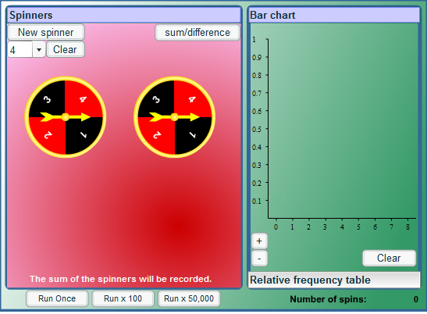
We're going to spin them both and add the numbers.
What possible sums might you get?

What is a probability of getting a sum of 7?

What is a probability of getting a sum of 10?

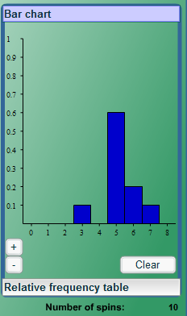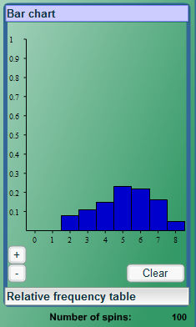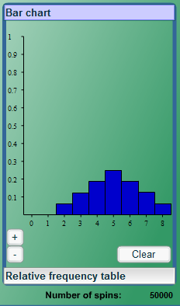
What is the probability of getting the sum of 5? (use the bar charts above)
Explain your reasoning.

What is the probability of getting the sum of 4? (use the bar charts above)
Explain your reasoning.

What is the least likely/most likely sum to occur? Give a detailed explanation for your answers.

Challenge
Now imagine that you have two 1-5 spinners.
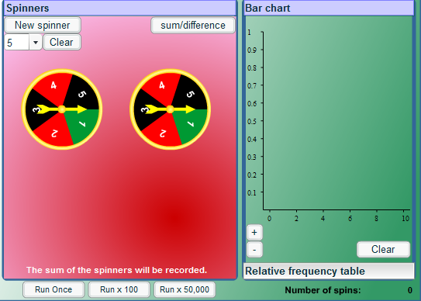

Describe in as much detail as you can what the relative frequency bar chart would look like after running the spinners 10 times, 100 times and 50,000 times.
Try to provide a good explanation to convince us that your description of the bar chart is correct.

